Avaya VirtualQ Connector

Installation and Deployment Guide

Software Version: # 3.4.1

Contents

1.1 Windows Pre-requisites 3

1.2 Avaya Pre-requisites 3

2.0 Installation Process 3

3.0 Configuration 5

4.0 AvayaVQ Service 18

5.0 Logs Path 19

6.0 Vector Configuration 20

## 1.1 Windows Pre-requisites

Installation of this product is supported on the following operation systems and versions:

* Windows Server 2012 x64
* Windows Server 2008 x64 R2
* Windows Server 2008 x64
* Windows Server 2008 x86 R2
* Windows Server 2008 x86
* Windows Server 2003 x64
* Windows Server 2003 x86

## 1.2 Avaya Pre-requisites

The following Avaya software packages must be Configured for the connector to work

* Avaya Aura Communication Manager 5.2 x or Better
* Avaya Aura Enablement Services V 5.2 or Better

## 2.0 Installation Process

Before installing the application please make sure that you have administrative rights to install the application.

­­­­­­­Start the Installation by running the setup.exe file. To run as administrator, do a right click on the setup.exe and click on **“Run As Administrator”**

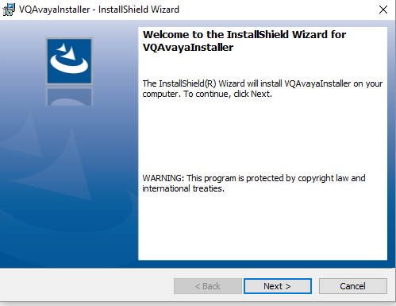­­­­

Click Next

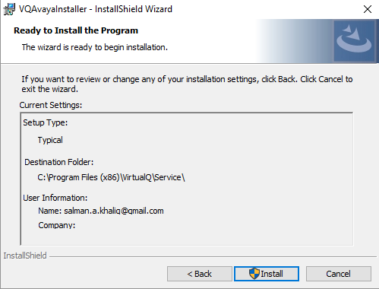

Click Install and the Process will install the service.

## 3.0 Configuration

Edit the Config.XML file in a Notepad Editor

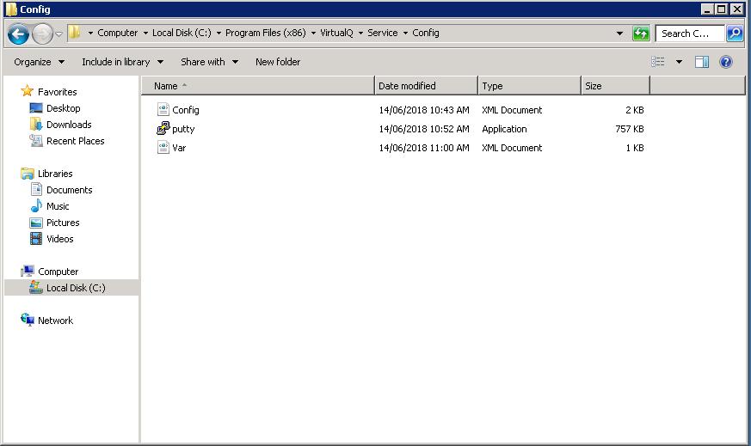

Configure the XML File

<?xml version="1.0" encoding="utf-8"?>

<configuration>

<general>

<isMonitorEnabled>true</isMonitorEnabled>

<isUcidEnabled>false</isUcidEnabled>

<UseExtAppToWrite>true</UseExtAppToWrite>

<path>C:\Program Files (x86)\VirtualQ\Service\</path>

<wdelay>200</wdelay>

<params>200</params>

</general>

<aesserver>

<ipaddress>10.1.0.133</ipaddress>

<unsecureport>4721</unsecureport>

<username>avaya</username>

<password>avayapassword</password>

<switchname>CM</switchname>

<switchIpInterface>10.1.0.113</switchIpInterface>

<aesprotocolversion>6.3.3</aesprotocolversion>

<sessioncleanupdelay>60</sessioncleanupdelay>

<sessionduration>300</sessionduration>

</aesserver>

<vdns>

<vdn>

<normalvdn>9850,9851</normalvdn>

<highvdn>9889</highvdn>

<skill>1</skill>

<splitExten>0000</splitExten>

<lineID>3069</lineID>

<lineGroup>212</lineGroup>

<IsActiveVar>VE</IsActiveVar>

<virtualqconfiguration>

<apikey>DSH2XzCCAeu44MhT29xj</apikey>

<apibaseaddress>https://api.virtualq.io</apibaseaddress>

<enabled>true</enabled>

<proxyadd>NA</proxyadd>

<proxyport>0</proxyport>

<proxyuser></proxyuser>

<proxypass></proxypass>

</virtualqconfiguration>

</vdn>

</vdns>

<CM>

<ip>10.1.0.113</ip>

<user>smstest</user>

<password>smstest01</password>

<pin></pin>

<delay>30</delay>

<reasons>ACD,Avail</reasons>

</CM>

</configuration>

|  |  |  |
| --- | --- | --- |
| General | | |
| Parameter | Value | Description |
| isMonitorEnabled | true\false | * Enable or Disable AES Monitoring to update Queue Events. * AES Server parameters must be configured for this to work. * The High VDN Must also be configured to be monitor the events |
| isUcidEnabled | true\false | * Enables the UCID Database Insertion * The UCIDInsert.exe.config must be configured to enable insertion into the Database * isMonitorEnabled needs to be enabled for this parameter to work |
| UseExtAppToWrite | true\false | * This value must be set to true for the application to update the Activation Variable in the CM * The CM Parameters must be configured to this to work. * The AES Parameters need to be set if AesFlag is set to true in vars.xml |
| path | %InstallDIr | * This parameter must be set to the path where the Service has been installed * The default value is “C:\Program Files (x86)\VirtualQ\Service” |
| wdelay | 200 | * Internal Parameters used if UseExtAppToWrite * Changing of this parameter is not recommended unless requested by the Admin |
| params | 200 | * Internal Parameters used if UseExtAppToWrite * Changing of this parameter is not recommended unless requested by the Admin |
|  |  |  |
| AES Server | | |
| Parameter | Value | Description |
| ipaddress | x.x.x.x | * IP Address of the AES. (Virtual IP Address in case of HA ). * Set the Value to "NA" if isMonitorEnabled is set to false & AesFlag is set to false in vars.xml |
| unsecureport | 4721 | * AES Port (Non Secured). * Can be Set to blank if ipaddress is set to “NA” |
| username |  | * Username of the CT User. * Can be Set to blank if ipaddress is set to “NA” |
| password |  | * Password of the CT Password. * Can be Set to blank if ipaddress is set to “NA” |
| switchname |  | * CM Switch Name configured in AES. * Can be Set to blank if ipaddress is set to “NA” |
| switchIpInterface | x.x.x.x | * IP Interface of the Switch. * Can be Set to blank if ipaddress is set to “NA” |
| aesprotocolversion | 6.3.3 | * Version of the AES. * Can be Set to blank if ipaddress is set to “NA” |
| sessioncleanupdelay |  | * Clean Up delay must be set to 180. * Can be Set to 0 if ipaddress is set to “NA” |
| sessionduration |  | * Session Duration must be set to 60. * Can be Set to 0 if ipaddress is set to “NA” |

AES Parameters Reference

The following information can be obtained from the AES Web Interface https://aesipaddress.

**AES Port (**unsecureport**)**

Login to AES and Goto Networking - > Ports. Please check the Unencrypted port is enabled

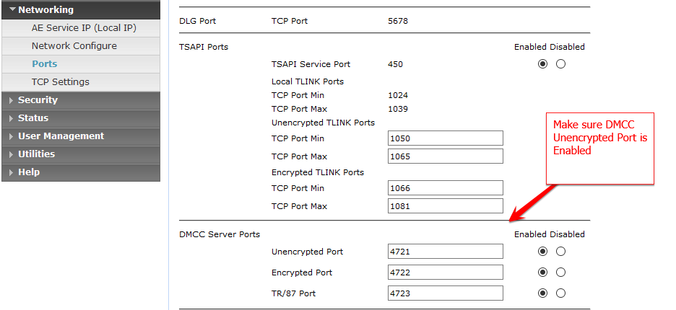

Goto Security - > Standard Reserved Ports. Please make sure that the HTTP Port 80 is enabled.

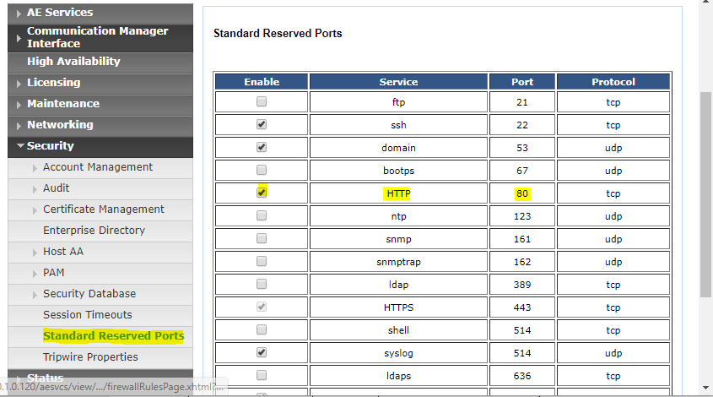

**AES Username & Password (**username & password**)**

Login to AES and Goto User Management - > List All Ports. Create a user with the following settings

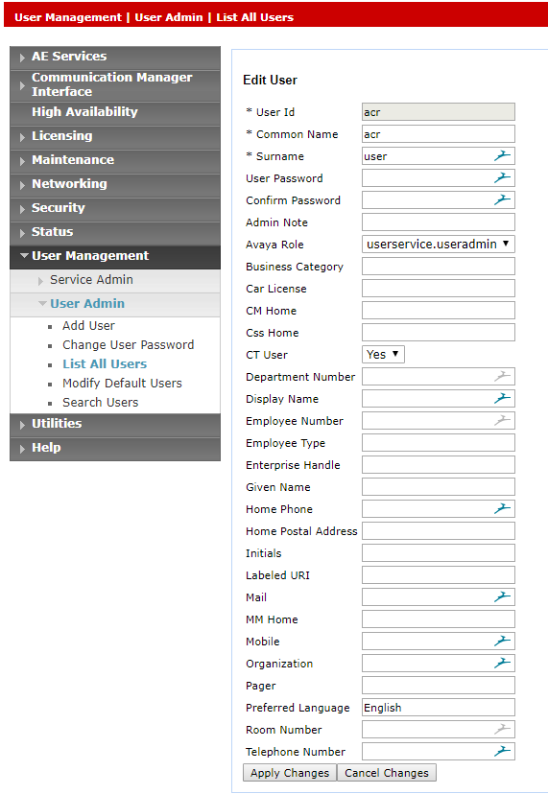

Goto Security - > Security Database -> CTI Users -> List All Users > Edit

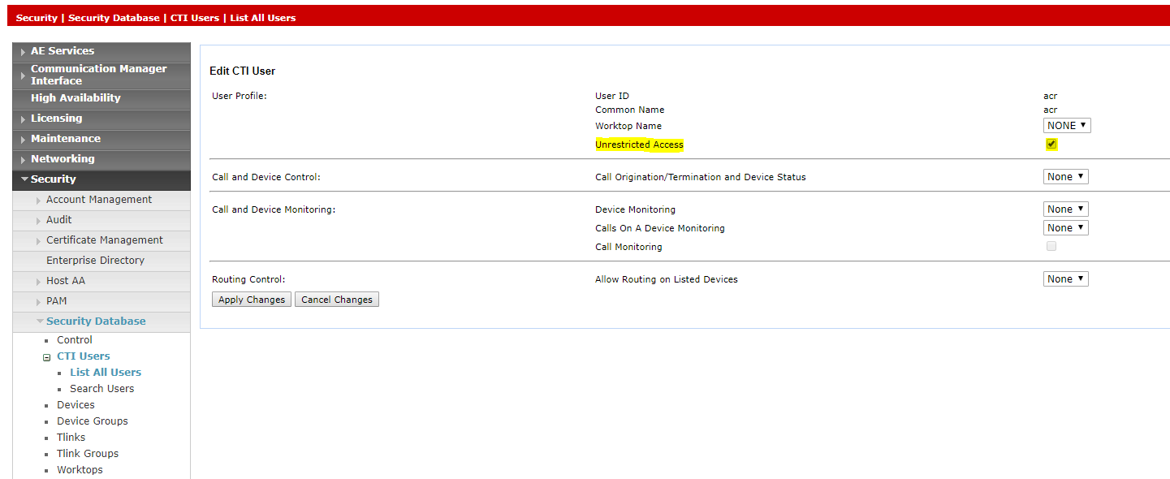

Make sure that user has the Access to monitor the VDNs

**CM Switch Name (**switchname**)**

Login to AES and Goto Communication Manager Interface - > Switch Connections. The CM Name can be retrieved from the Connection Name. In case of multiple CM, separate application needs to be run.

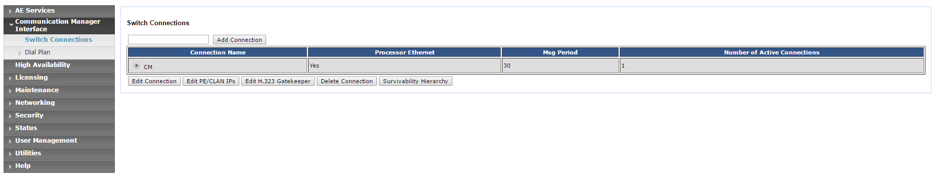

The IP address can be retrieved by pressing the Edit Connection Button

**AES Protocol Version (**aesprotocolversion**)**

The AES version can be obtained by logging into the AES Web Interface. It will appear on the top right corner

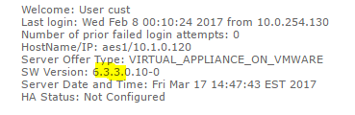

Possible Versions

3.0

3.1

4.0

4.1

4.2

5.2

6.1

6.2

6.3

6.3.1

6.3.3

7.0

For Version 7.1 please use 7.0 as the version number

|  |  |  |
| --- | --- | --- |
|  |  |  |
| VDN | | |
| Parameter | Value | Description |
| normalvdn | 0000 | * Normal VDN required for Monitoring if IsUcidEnabled is set to true * Multiple VDNs can be given separated by comma |
| highvdn |  | * High VDN required for monitoring of the call to update VirtualQ when the agent picks up the call |
| skill |  | * Skill of the queue for which the stats need to be collected * This value is required and needs the CM Parameters to be configured |
| splitExten | 0000 | * Not Required anymore |
| lineID |  | * VirtualQ LineID that corresponds to the skill |
| lineGroup |  | * VirtualQ LineGroup that corresponds to the skill |
| IsActiveVar |  | * Variable to Set the ISActive on the CM against the skill. * Write permissions are required on CM for this option to work |

Multiple VDNs can be created using multiple tags.

|  |  |  |
| --- | --- | --- |
|  |  |  |
| CM | | |
| Parameter | Value | Description |
| ip | x.x.x.x | * IP Address of the CM |
| user |  | * CM Username with right to run monitor bcms, status and list commands. * Write permissions will be required |
| password |  | * CM Password |
| pin |  | * Leave Blank if not required |
| delay | 30 | * Interval in seconds after which the CM stats are retrieved |
| reasons |  | * Reasons for which the agent will be considered as staffed * Multiple reasons can be provided separated by comma |

**CM Username & Password Details**

Login to the CM Interface and Create the following user with the following privileges

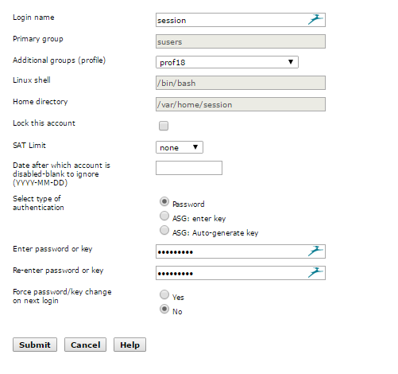

**Variable Configuration**:

Edit the Vars.xml for configuring the Variables

<sec_prefix>https://</sec_prefix>

<AesFlag>true</AesFlag>

**AesFlag=true**

If AesFlag is set to **true** then the Application will use SMS Webservice from AES to update the variables and the Variable Assignments and position will be required

Multiple tags can be used for all the variables in the VDN Tag list

<VE>

<assignment>Assignment_3</assignment>

<position>73</position>

</VE>

The Variables can be Created anywhere in the CM by using the change variable command

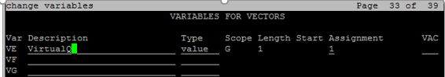

Open AES SMS page by opening https://aesIPAddress/smsxml/smsxml_test.php

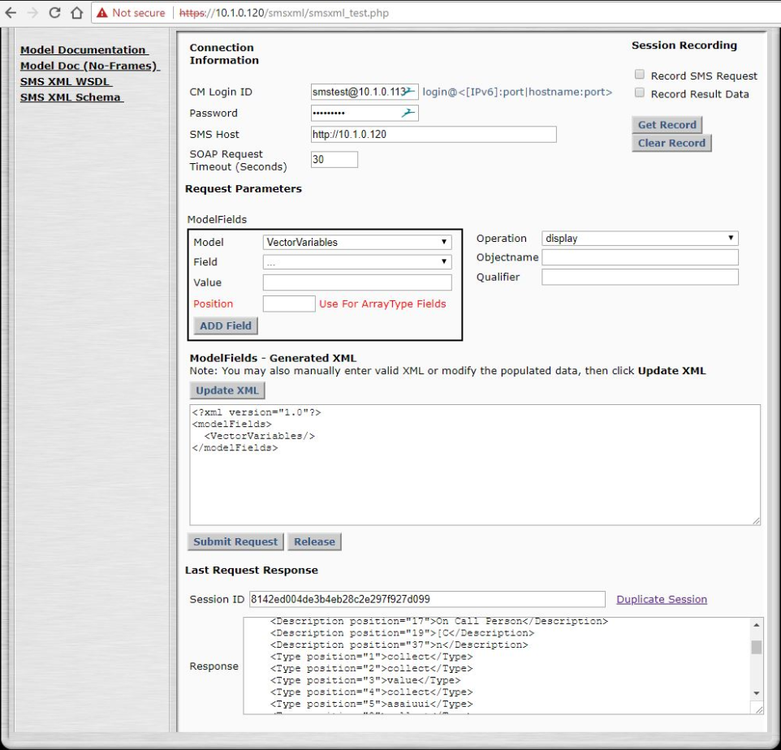

Get the Assignment and Position of each variable

CMLogin ID: CM User@CM IP Address

Password: CM Password

SMS Host : <http://aesIPAddress>

**AesFlag=false**

If AesFlag is set to **False,** then the Application will use CM directly using an SSH session to write the variables.

Each variable in the VDN Tag list needs to be the first Variable on any page.

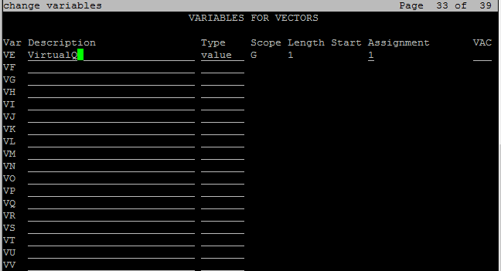

Description: VirtualQ

Type: value

Assignment: 0

|  |  |  |
| --- | --- | --- |
|  |  |  |
|  |  |  |
| Virtualqconfiguration | | |
| Parameter | Value | Description |
| apikey |  | * Key provided by VirtualQ Dashboard Interface |
| apibaseaddress |  | * <https://api.virtualq.io> |
| enabled | true\false | * Needs to be set to true |
| proxyadd | NA | * Give the proxy Value if proxy is required * NA if not required |
| proxyport | 0 | * Proxy Port * 0 if not required |
| proxyuser |  | * Proxy Port |
| proxypass |  | * Proxy Password |

## 4.0 AvayaVQ Service

**The service needs to be started the first time.**

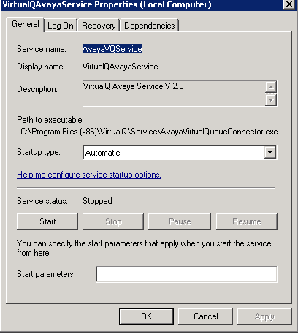

## 5.0 Logs Path

C:\Program Files (x86)\VirtualQ\Service\logs

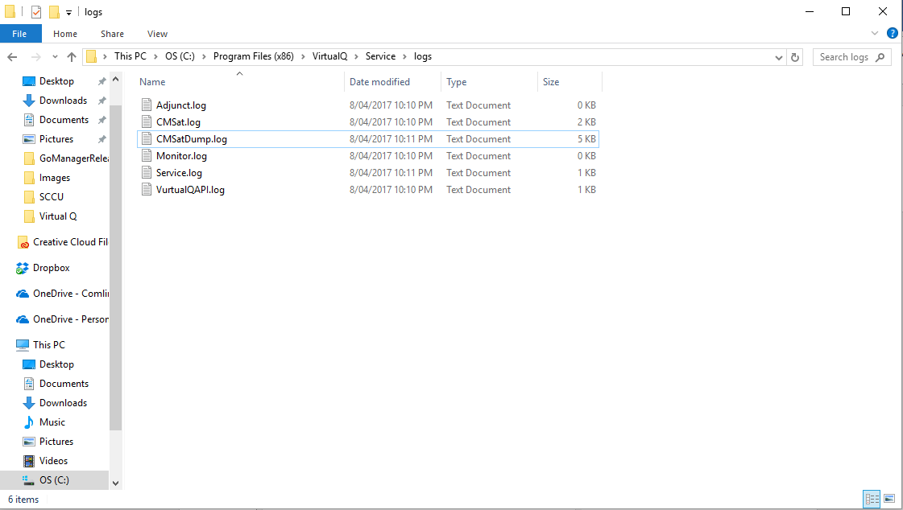

## 6.0 Vector Configuration

**High Priority VDN**

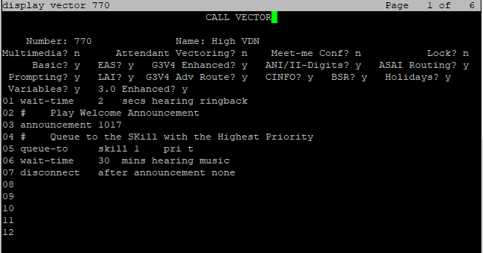

# 1017

Hello, Glad to have you back. The next available agent will be with you momentarily. Thanks for using Virtual Queue



**Normal Priority VDN**

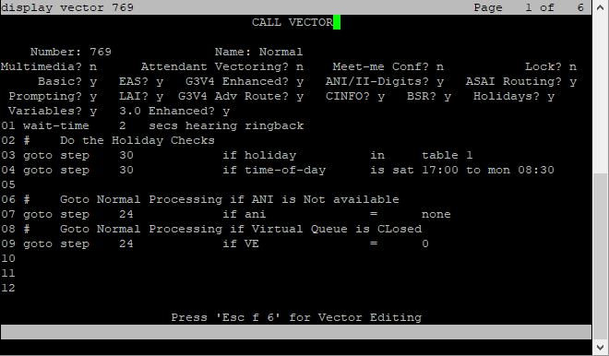

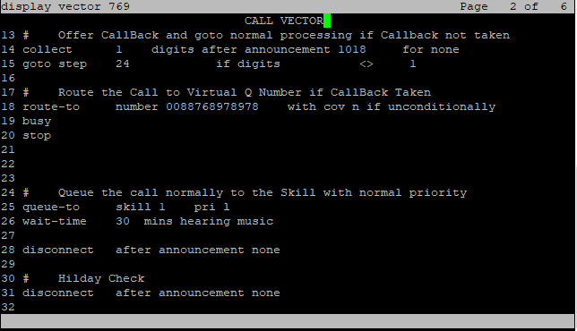

# 1018

We are sorry, but all lines are currently busy, If you would like to use our special waiting service, please press 1, we will hold your position in line and will call you back when you are up. If you rather want to wait for the next available agent, please stay on the line



**Call Volume Parameter In CM**

